WATER
Water consumption
IDIADA’s activities at L'Albornar require the use of a significant amount of water. This water has two origins:
- Water from our own wells
- Water from external sources
The main uses of this water are as follows:
- Vegetation and landscaped areas irrigation
- Wet braking surfaces, test hills, fatigue and wet handling tracks
- Toilets, changing rooms and kitchen
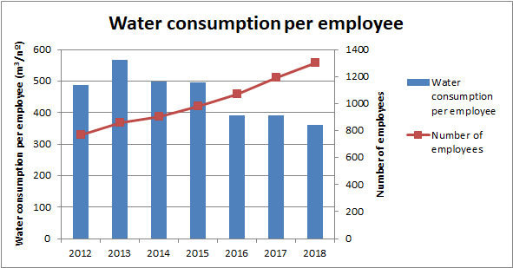
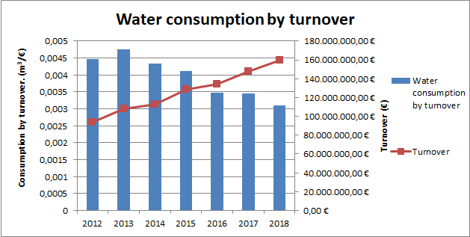
Since 2013, as can be seen in the graphs, a downward trend in water consumption has continued, thanks largely to the implementation of measures aimed at improving efficiency in water consumption, among which the following stand out:
- Using plant species with lower water requirements, which allows for a reduction in the volume and periodicity of irrigation.
- Use of double-flush mechanisms in the toilet cisterns.
- Improvements in the irrigation water recovery networks on the test tracks.
- Improvement in the irrigation system, with more efficient nozzles, which reduce water consumption.
In addition, in the last year water consumption has been further reduced following the implementation of a series of improvements to the Brake Track. These measures were aimed at renewing the irrigation system with the intention of improving the distribution of water on the braking surfaces and increasing water recovery ratios.

WASTE
Waste generation
In 2018, Idiada's daily activity generated 33 different types of waste, all of them managed by authorized companies.
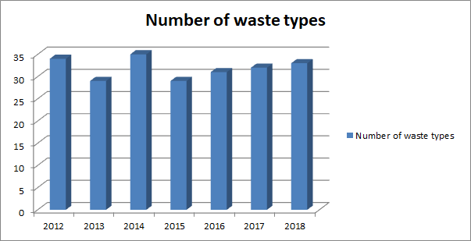

In total numbers per worker, 1.3 tons per worker were generated in 2018, of which 0.5 tons corresponded to hazardous waste and 0.79 tons to non-hazardous waste.
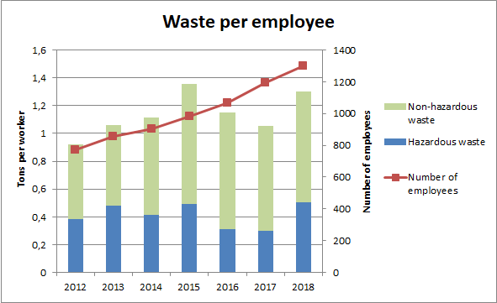
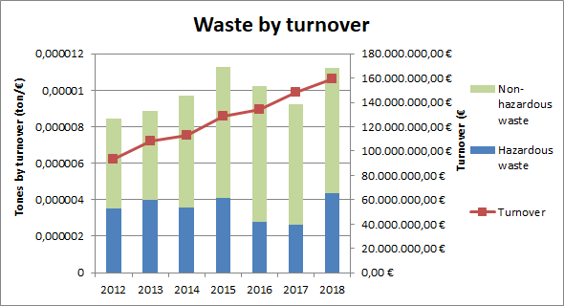
All the waste generated in Idiada is segregated at source according to its nature in order to facilitate its management and recovery, where possible.
In order to facilitate this, an information and awareness-raising campaign has been carried out for employees and customers, for which posters and information leaflets have been designed describing the appropriate way to segregate the different types of waste.

ATMOSPHERE
Emissions into the atmosphere
The nature of the activity developed in Idiada involves the use of different types of fuels, among which are: gasoline, diesel, LPG and LNG, which means the emission of CO2 into the atmosphere.
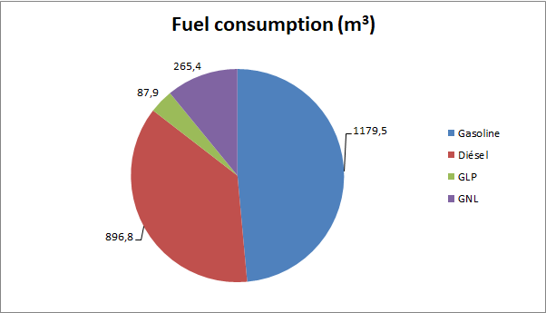
The trend followed in fuel consumption by turnover is declining, despite the fact that, in the last year, there has been a slight upturn in gasoline consumption.
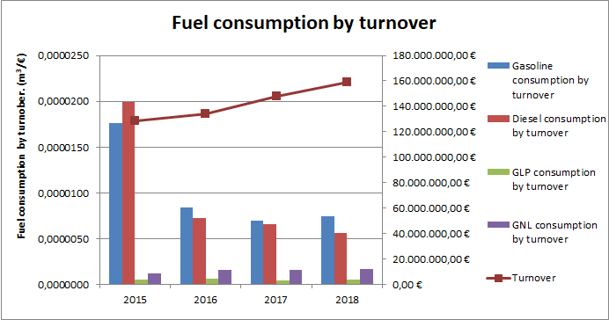

ELECTRICITY
Consumption
In recent years, Idiada has implemented a series of measures with the intention of reducing electricity consumption. These measures include the following:
- Systematic installation of network analysers in main switchboards and more efficient VRV-type air-conditioning equipment, screw compressors with inverter technology, with remote management to improve control.
- Replacement of fluorescent tubes with similar more efficient ones.
- Lighting changes by new technologies, such as LED.
- Implementation of a new lighting system in the gas station area consisting of LED technology equipment with built-in presence sensors.
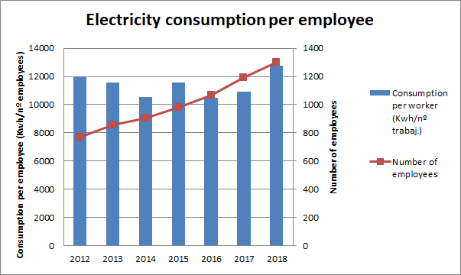
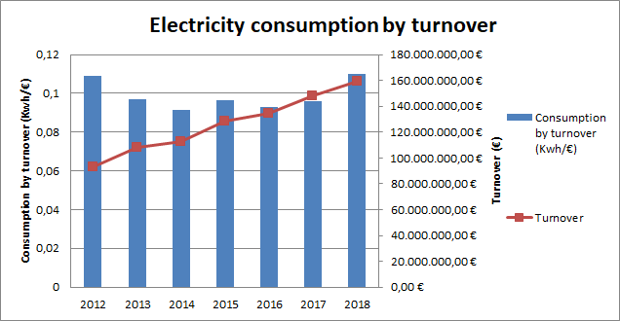

The eagerness to continue being a reference in the sector and to offer its clients the best conditions for their tests, has led Idiada to promote the electric vehicle tests in its facilities.
This is why during 2018, the consumption of electrical energy, both per worker and per turnover has increased.
ENVIRONMENTAL MANAGEMENT PROGRAM
Continuous improvement is a basic pillar on which Idiada's environmental policy is based. For this reason, work continues on the implementation of measures that allow the company to improve its behaviour towards the environment.
To this end, several objectives have been established for the year 2019, which are detailed below:
Objective 1: To reduce total water consumption in Idiada (L'Albornar, Les Planes and Idiada 2) by 5% with respect to consumption in 2018.
In order to achieve this, training campaigns will continue to promote the sustainable use of water and additional reading systems will be installed to mark patterns of conduct in the distribution networks and detect possible leaks as quickly as possible.
Objective 2: To reduce by 5% the tons of banal waste generated in Idiada (L'Albornar, Les Planes and Idiada 2) with respect to those generated in 2018.
Throughout 2019 it is planned to install a composting equipment that will transform the organic waste from the kitchen into compost that can be used as fertilizer within the Idiada facilities.

